农药分析图谱 GsBP-5MS 1525-3002
Column: GsBP-5MS, 30m x 0.25mm x 0.25um
Cat. No.: 1525-3002
Oven: 150C 4C/min to 275C hold
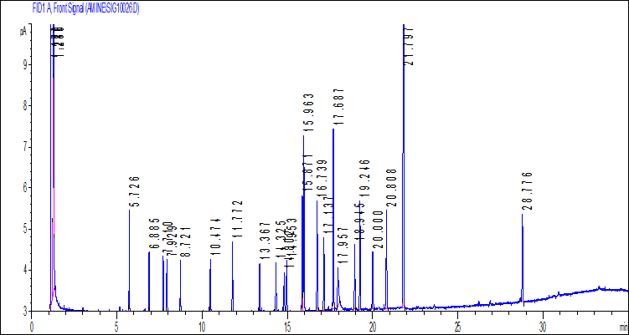

1 | 2,4,5,6-Tetrachloro-m-xylene(IS) | 12 | Dieldrin
2 | α-BHC | 13 | p,p’-DDE
3 | β-BHC | 14 | Endrin
4 | γ-BHC | 15 | Endosulfan II
5 | δ-BHC | 16 | p,p’-DDD
6 | Heptachlor | 17 | Endrin aldehyde
7 | Aldrin | 18 | Endosulfan sulfate
8 | Heptachlor epoxide | 19 | p,p’-DDT
9 | γ-Chlordane | 20 | Endrin ketone
10 | Endosulfan I | 21 | Methoxychlor
11 | α-Chlordane | 22 | Decachlorobiphenyl(IS)

