多潘立酮与氟哌利多的分离-Zodiac C18 色谱柱

Column : C18 100mm*4.6mm, 3µm
Flow Rate: 1.5ml/min
Wave Length : 280nm
Temperature: 25°C
Runtime : 20 minutes
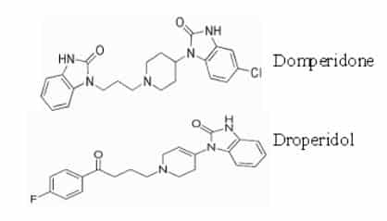
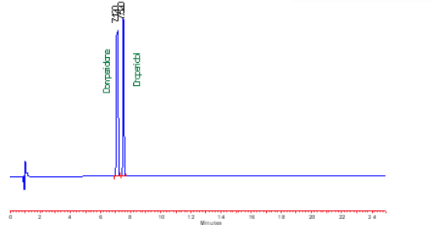

Preparation of Mobile Phase :
1.) Mobile Phase : A
Dissolve 5.0g of Ammonium Acetate in 1000ml of HPLC Grade Water
2.) Mobile Phase : B
Methanol HPLC Grade
3.) Gradient Program :
Time (min) | Mobile Phase-A(%V/V) | Mobile Phase- B(%V/V)
0-10 | 70 | 30
10-15 | 0 | 100
15-15.01 | 70 | 30
15.01-20 | 70 | 30
4.) Diluent : N,N Dimethylformamide
Domperidone Reference Solution (a) : (0.10 and 0.15 mg/ml) Weight accurately about 10mg of Domperidone CRS and 15mg of Droperidol CRS into a 100ml Volumetric flask dissolve and dilute to volume with Diluent and mix Inject 10µl of Domperidone Reference Solution (a) in duplicate and calculate Resolution between Domperidone and Droperidol.
Acceptance Criteria:
Resolution between Domperidone and Dropridol should not be less than 2.0
Column Name : Zodiac C18 Column
Compound Name : Droperidol, Domperidone

